Chapter 14
Providing Help
About This Chapter
In this chapter, you’ll learn about the different ways that you can display user assistance (Help) from within a Web application. You’ll learn how to use the HTML Help Workshop to create compiled Help files and how to display those files from a Web application interactively.
Before You Begin
To complete this chapter, you must:
- Be familiar with HTML
- Be comfortable creating Web forms in HTML mode
Lesson 1: Adding Help to Web Applications
Web applications can display help in several ways: as ToolTips for controls, as Web forms or HTML pages, or as compiled HTML Help files. In this lesson, you’ll learn to use these different techniques from within Web forms.
After this lesson, you will be able to
- Add ToolTips to server controls and HTML controls on a Web form
- Display Help as a Web form or an HTML page in a browser window
- Control the size and focus of the browser window displaying Help
- Display Help using the HTML Help Viewer
Estimated lesson time: 15 minutes
Displaying ToolTips
A ToolTip is a short, descriptive message that’s displayed when the user places the mouse pointer over a control and leaves it there for a couple of seconds. These messages are used throughout Microsoft Windows applications to provide helpful information about toolbar buttons and other graphical controls whose meaning might not otherwise be obvious. In a sense, ToolTips are subtitles for the icon-impaired. Figure 14-1 shows a ToolTip in action.

Figure 14-1. A ToolTip
Most server controls include a ToolTip property that you can set to the message you want to display. At run time, Microsoft ASP.NET outputs the ToolTip property as the control’s title attribute, which Microsoft Internet Explorer displays as a ToolTip. Only Internet Explorer displays the title attributes as ToolTips. Other browsers do not display ToolTips.
HTML controls do not include a ToolTip property. Instead, you can use the title attribute directly. The following HTML shows the difference between setting a ToolTip for a server control and setting one for an HTML control:
<asp:Button id="butOK" runat="server" Text="OK"
ToolTip="Submits purchase."></asp:Button>
<INPUT type="reset" value="Cancel" title="Cancels purchase.">
Not all controls include a ToolTip property or title attribute. In particular, the DropDownList and ListBox server controls do not provide a ToolTip property or a title attribute.
Displaying Help as Web Forms or HTML
Creating your Help content as Web forms or HTML pages is probably the simplest approach to providing user assistance. The Help files can reside in either the same project folder as your Web application or in a subordinate folder.
You use hyperlinks or other controls to display the Help in the browser, just as you would any other page, with one important difference: you usually want to display Help in a new window or in a separate frame from the rest of the Web application, as shown in Figure 14-2.
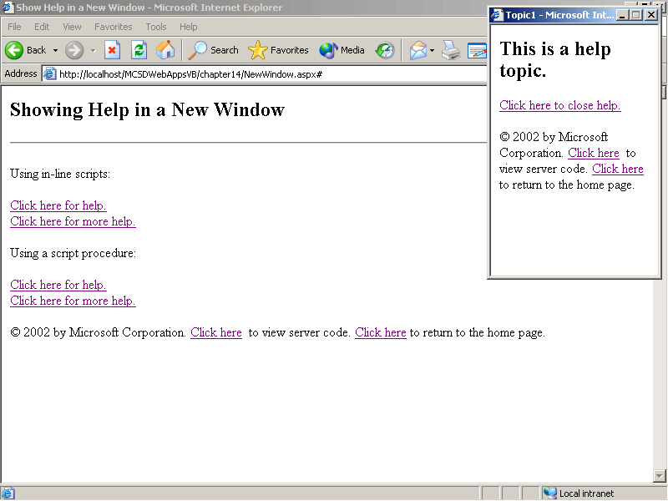
Figure 14-2. Displaying a Help browser window
Displaying Help in a separate browser window preserves the user’s place in the Web application and allows him or her to compare the Help to the current task being performed.
To display Help in a separate window, use the client-side window object’s open method, as shown in the following hyperlink:
<a href="#" onclick="window.open('topic1.aspx', 'helpwin').focus()">
Click here for help.</a>
The preceding HTML uses the onclick event to display the Help topic in a new browser window on top of the Web application’s window. Setting the href attribute to "#" simply links to the current location in the Web application, rather than directing the user to a new location. The first argument to the open method specifies the Help topic to display; the second argument names the new window so that subsequent Help topics are directed to the same window. Finally, the focus method ensures that the Help window is displayed on top of the Web application.
Other Help hyperlinks within the Web application can use the same onclick script to display different topics in the same window. If your application includes more than one Help hyperlink per Web form, it’s a good idea to place the script in a procedure and call it from the onclick procedure, as shown here:
VBScript
<HTML>
<HEAD>
<title>WebForm1</title>
<script language="vbscript">
' Shows a Web form or HTML page in a small browser window
' and switches the focus to that window.
Sub ShowHelp(topicName)
Dim HelpWindow
' Display topic in named window.
Set HelpWindow = window.open(topicName,
"helpwin","left=600,height=300,width=200")
' Displays the window on top.
HelpWindow.focus
End Sub
</script>
</HEAD>
<body>
<h2>Show Help in a New window</h2>
<A onclick="ShowHelp('topic1.aspx')" href="#">Click here
for help.</A>
<BR>
<A onclick="ShowHelp('topic2.aspx')" href="#">Click here
for more help.</A>
</body>
</HTML>
JScript
<HTML>
<HEAD>
<script language=jscript>
// Shows a Web form or HTML page in a small browser window
// and switches the focus to that window.
function ShowHelp(topicName)
{
var HelpWindow;
// Display topic in named window.
HelpWindow = window.open(topicName,
"helpwin","left=600,height=300,width=200");
// Displays the window on top.
HelpWindow.focus();
}
</script>
</HEAD>
<body>
<h2>Show Help in a New window</h2>
<a href="#" onclick="ShowHelp('topic1.aspx')">Click here for
help.</a>
<br>
<a href="#" onclick="ShowHelp('topic2.aspx')">Click here for
more help.</a>
</body>
</HTML>
Within the Help topic, you can use the window object’s close method to provide a link to close the Help window within the Help topic, as shown here:
<a href="#" onclick="window.close()">Click here to close help.</a>
There are other ways to display a topic in a named window, such as using the target attribute of a hyperlink. However, those techniques make it more difficult to ensure that the Help window is displayed on top of the Web application.
Displaying HTML Help
You can use the window object’s showHelp method to display HTML Help files, regular HTML files, or Web forms using the HTML Help Viewer (hh.exe). An HTML Help file consists of topic files written in HTML that have been compiled into a single, compressed file that provides additional Help features.
The showHelp method displays topics in the HTML Help Viewer, which by default is displayed on top of the Web application’s browser window, as shown in Figure 14-3.
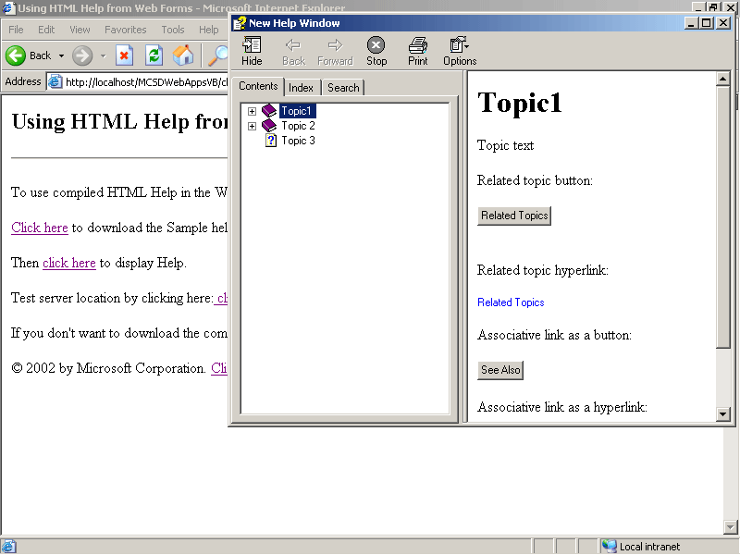
Figure 14-3. The HTML Help Viewer
To display a Web form or an HTML page using showHelp, specify the Web form or HTML page file name as the first argument of the method, as shown here:
<a href="#" onclick="window.showHelp('Topic1.aspx')">Show Help</a>
The preceding HTML displays the Web form Topic1.aspx when the user clicks the Show Help hyperlink. The Topic1.aspx file in not a compiled Help file—it is simply a Help topic written using ASP.NET. Using showHelp in this way gives you the advantage of the window always being on top of the Web application—even when the Web application has the focus.
The showHelp method can also display topics from compiled Help files. These files are made up of HTML pages that are compiled into a single file (.chm) using the HTML Help Workshop. When you work with compiled Help files, showHelp identifies the topic to display using a context ID that is mapped to a topic file name during compilation.
To display a topic from a compiled HTML Help file, specify the compiled file name and topic file name as the first argument of the showHelp method, as shown here:
<a href="#" onclick="window.showHelp('c:\\Help\\HelpSample.chm')">
Show Help</a><br>
The preceding HTML displays the compiled file named HelpSample.chm. Note that the compiled Help file must be downloaded and stored on the user’s machine. Using compiled Help files has the following advantages over storing and displaying Help files as separate Web forms or HTML pages:
- Reduced size
Compiling Help compresses the topics so that their total size is much less than the total of the individual source topics.
- Contents, Index, and Search tools
The HTML Help Workshop includes tools for creating these features and adding them to your Help system.
- Embedded display
The HTML Help Microsoft ActiveX control and Java applet allow you to display your Help within the browser window rather than as a separate window.
- Ease of localization
Because HTML Help maps topic file names to context IDs, it’s possible to have multiple compiled Help files written in different natural languages that all use the same set of context IDs.
Compiling HTML Help has a couple of limitations that you should be aware of as well:
- Source files must be in HTML format
Web forms can’t be compiled into .chm files.
- The entire compiled file must be downloaded to the user’s machine
If you have a large Help file and your users are connected via modem, it can take a long time to load Help the first time. Once the Help file is downloaded, however, it can be accessed quickly.
The following lessons discuss creating compiled HTML Help files and using those files from Web applications in more detail.
Lesson 2: Using the HTML Help Workshop
Microsoft Visual Studio .NET includes the HTML Help Workshop, which is installed in a separate location on the developer’s machine. In this lesson, you’ll learn how to use the HTML Help Workshop to create a compiled Help file that includes a table of contents, an index, and full-text search capabilities.
After this lesson, you will be able to
- Create a new Help project
- Add topics to a Help project and compile those topics into a single Help file
- Build a table of contents automatically during compilation
- Modify an automatically generated table of contents
- Add index keywords to Help topics
- Create different types of cross-references between topics within a Help file
- Add special features such as associative links and Related Topics links to Help topics
- Enable full-text searches within a Help file
- Compile and preview Help from the HTML Help Workshop or from the command line
Estimated lesson time: 30 minutes
Creating HTML Help
An HTML Help file is made up of individual HTML pages, each representing a single Help topic. Each Help topic can include keywords that are included in the index and cross-references to other topics. HTML Help projects include the types of files described in Table 14-1.
Table 14-1. HTML Help Project Files
File type | Use to
Help topic (.htm) | Create content to display in Help
Project (.hhp) | Define how the project is compiled and which Help topic, contents, and index files to include
Contents (.hhc) | Create a table of contents for the Help file
Index (.hhk) | Create an index for the Help file
Search stop list (.stp) | Exclude specific words from searches
Compiled (.chm) | Deploy the completed Help file
The HTML Help Workshop provides tools to organize, edit, and compile these files. By default, Visual Studio .NET installs the HTML Help Workshop in the Program Files\HTML Help Workshop folder during setup.
To create a new HTML Help project, follow these steps:
- From the HTML Help Workshop File menu, choose New. The New dialog box opens.
- In the New dialog box, select Project and click OK. The New Project Wizard opens. The wizard lets you convert an existing WinHelp project or create a new HTML Help project.
- Click Next to create a new project. The wizard displays the Destination page.
- Type the location and name of the Help project file you want to create, and then click Next. The wizard displays the Existing Files page.
- Select the check boxes for any contents, index, or topic files you’ve already created, and click Next. If you select any of these existing files, the wizard prompts you for the location of each of the selected file types. Otherwise, the wizard creates a new, empty Help project, as shown in Figure 14-4.
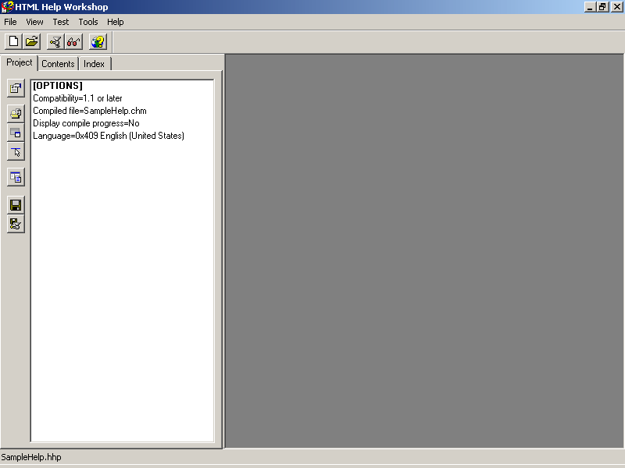
Figure 14-4. A new, empty Help project
Using HTML Help Workshop is fairly simple. You use the Project, Contents, and Index tabs on the left pane to edit the contents of the project, contents, and index files. The buttons at the top of the pane create new files, open existing files, compile the project, display the compiled project, and display HTML Workshop Help.
To add topic files to the Help project, follow these steps:
- Click the New button on the toolbar, select HTML File in the New dialog box, and then specify a title for the topic. The Workshop creates a new Help topic file, as shown in Figure 14-5.
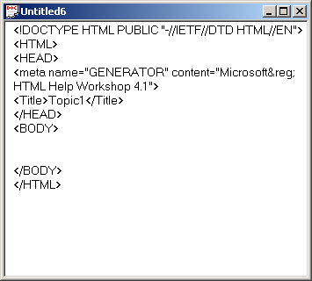
Figure 14-5. Creating topic files
- Save the HTML file, and then click Add/Remove Topic Files on the Project tab. The Topic Files dialog box opens.
- Click Add, and then select the files to add to the project. Click Open.
- Click OK to close the Topic Files dialog box. The Workshop adds the file to the project.
The HTML Help Workshop provides only basic text-editing capabilities. In general, you author your Help topic files in a full-featured HTML editor, such as Microsoft FrontPage, and then use the Workshop to create the project file and compile the Help.
Setting Project Options
Help project options are displayed on the Project tab of the HTML Help Workshop. These options are stored in the Help project file (.hhp) in plain text and can be modified using the HTML Help Workshop or a text editor such as Notepad.
To set project options in the HTML Help Workshop, on the Project tab, click Change Project Options. The Workshop displays the Options dialog box, as shown in Figure 14-6.
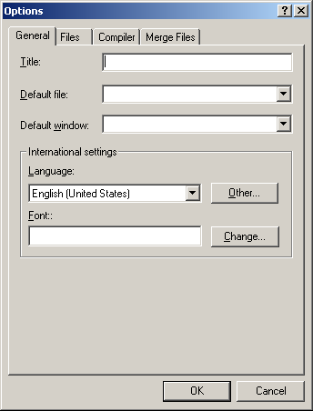
Figure 14-6. Setting options
The project options let you specify a title for the Help project, locale information about the project, how the contents and index files are created, whether to support searching, and other features. These items are placed in the OPTIONS section of the project file. For example, the following project options create index and contents files automatically when compiling a Help file named HelpSample.chm, which displays the title “HTML Help Sample” in the Help window:
[OPTIONS]
Auto Index=Yes
Auto TOC=9
Compatibility=1.1 or later
Compiled file=HelpSample.chm
Contents file= Contents.hhc
Default topic=topic1.htm
Display compile progress=No
Full text search stop list file=Search.stp
Index file=Index.hhk
Language=0x409 English (United States)
Title=HTML Help Sample
The project file also includes a FILES section that lists the Help topic files to compile. The order of the files in this section determines the order of items in the contents file when Auto TOC is selected in the OPTIONS section. For example, the following topic files appear in sequential order in contents:
[FILES]
topic1.htm
topic1a.htm
topic1b.htm
topic2.htm
topic3.htm
Building Tables of Contents
When building the table of contents automatically, the HTML Help Workshop uses the heading level of the topic and its order in the FILES section of the project file to determine how the table of contents is organized.
The Workshop puts <h1> headings at the top level, <h2> headings under those, and so on until a new <h1> heading is encountered. If you have multiple heading levels within a single topic, the Workshop creates subordinate contents items for each of those headings—even though they all represent the same Help topic. For this reason, it’s best to use only one HTML heading element per Help topic when generating contents automatically.
For example, the following FILES section includes topic files with three heading levels, as indicated by their file names:
[FILES]
topic1.htm
topic1a.htm
topic1b.htm
topic2.htm
topic2a.htm
topic2b.htm
topic2bi.htm
topic2bii.htm
topic3.htm
At run time, the generated contents files appear as shown in Figure 14-7.
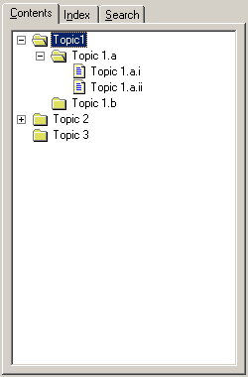
Figure 14-7. Automatic table of contents
The Workshop stores the generated table of contents in an HTML file. You can generate an automatic table of contents, turn off Auto TOC in the project file, and then edit the generated contents file to customize the table of contents.
To edit a contents file, click the Contents tab in the HTML Help Workshop. The Workshop displays the contents, as shown in Figure 14-8.
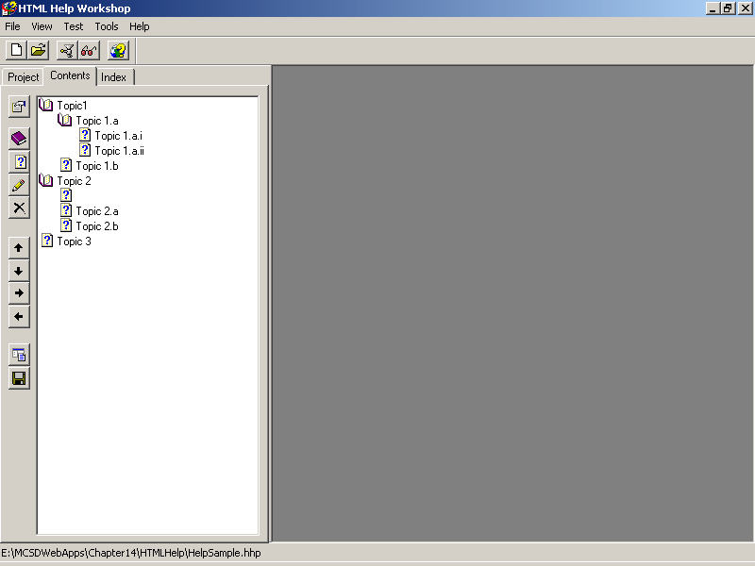
Figure 14-8. Editing the contents file
One thing you might have noticed in the automatic contents shown in Figure 14-8 is that the icons for top-level topics aren’t consistent. For instance, Topic 3 shows a page icon rather than a book icon.
To change the icon displayed for a topic, follow these steps:
- On the Contents tab, select the contents topic, click Edit Selection, and then in the Table Of Contents Entry dialog box, click the Advanced tab, as shown in Figure 14-9.
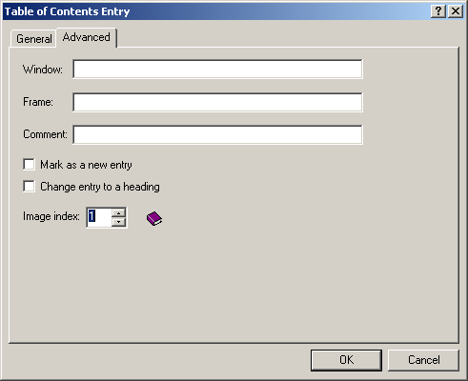
Figure 14-9. Changing the contents entry icon
- Select the image to use for the entry in the Image Index list box, and then click OK.
The contents file is stored as an HTML file that uses object elements to specify the contents items, as shown by the following HTML:
<!DOCTYPE HTML PUBLIC "-//IETF//DTD HTML//EN">
<HTML>
<HEAD>
<meta name="GENERATOR" content="Microsoft&reg; HTML Help Workshop 4.1">
<!-- Sitemap 1.0 -->
</HEAD><BODY>
<UL>
<LI> <OBJECT type="text/sitemap">
<param name="Name" value="Topic1">
<param name="Local" value="topic1.htm">
</OBJECT>
<UL>
<LI> <OBJECT type="text/sitemap">
<param name="Name" value="Topic 1.a">
<param name="Local" value="topic1a.htm">
</OBJECT>
<UL>
<LI> <OBJECT type="text/sitemap">
<param name="Name" value="Topic 1.a.i">
<param name="Local" value="topic1ai.htm">
</OBJECT>
<LI> <OBJECT type="text/sitemap">
<param name="Name" value="Topic 1.a.ii">
<param name="Local" value="topic1aii.htm">
</OBJECT>
</UL>
<LI> <OBJECT type="text/sitemap">
<param name="Name" value="Topic 1.b">
<param name="Local" value="topic1b.htm">
<param name="ImageNumber" value="1">
</OBJECT>
</UL>
<LI> <OBJECT type="text/sitemap">
<param name="Name" value="Topic 2">
<param name="Local" value="topic2.htm">
</OBJECT>
<UL>
<LI> <OBJECT type="text/sitemap">
<param name="Name" value="">
<param name="Local" value="topic2.htm">
</OBJECT>
<LI> <OBJECT type="text/sitemap">
<param name="Name" value="Topic 2.a">
<param name="Local" value="topic2a.htm">
</OBJECT>
<LI> <OBJECT type="text/sitemap">
<param name="Name" value="Topic 2.b">
<param name="Local" value="topic2b.htm">
</OBJECT>
</UL>
<LI> <OBJECT type="text/sitemap">
<param name="Name" value="Topic 3">
<param name="Local" value="topic3.htm">
<param name="ImageNumber" value="1">
</OBJECT>
</UL>
</BODY></HTML>
The HTML list elements specify the hierarchy of the items in the table of contents. The object elements specify the title, icon, location, and other information about the link. For example, the following contents item links to a company’s New Products page and opens the page in a new window when the user clicks it:
<OBJECT type="text/sitemap">
<param name="Name" value="New Products">
<param name="Local" value="http://www.mycompany.com/newproducts.htm">
<param name="WindowName" value="NewWindow">
<param name="Comment" value="Sample of text/sitemap params">
<param name="New" value="1">
<param name="ImageNumber" value="7">
</OBJECT>
Adding Index Entries
The HTML Help Workshop can automatically build an index file from object elements entered in the topic files. Within a topic file, an index entry is created as an ActiveX object with a specific classID, as shown in the following HTML:
<Object type="application/x-oleobject"
classid="clsid:1e2a7bd0-dab9-11d0-b93a- 00c04fc99f9e">
<param name="Keyword" value="Index Item 1">
<param name="Keyword" value="Index Item 1, Subitem a">
<param name="Keyword" value="Index Item 1, Subitem b">
</OBJECT>
The preceding HTML creates three index entries for that link to the topic file, as shown in Figure 14-10.
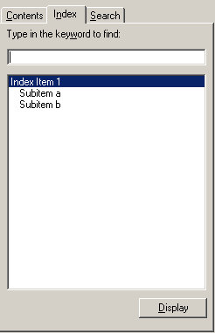
Figure 14-10. Automatic index entries at run time
The HTML Help Workshop does not automatically store index entries from topic files in the index file; however, you can add index entries to the index file to help organize or to supplement the automatic entries. The index file (.hhk) and the topic index entries are added together to create the index displayed in the compiled Help file. For example, the following index file (.hhk) is combined with the automatic entries to create the results shown in Figure 14-11:
<!DOCTYPE HTML PUBLIC "-//IETF//DTD HTML//EN">
<HTML>
<HEAD>
<meta name="GENERATOR" content="Microsoft&reg; HTML Help Workshop 4.1">
<!-- Sitemap 1.0 -->
</HEAD><BODY>
<UL>
<LI> <OBJECT type="text/sitemap">
<param name="Name" value="Index Item 1">
<param name="Name" value="Topic 1.b">
<param name="Local" value="topic1b.htm">
</OBJECT>
<LI> <OBJECT type="text/sitemap">
<param name="Name" value="Index Item 2">
<param name="Name" value="Topic 2.a">
<param name="Local" value="topic2a.htm">
</OBJECT>
</UL>
</BODY></HTML>
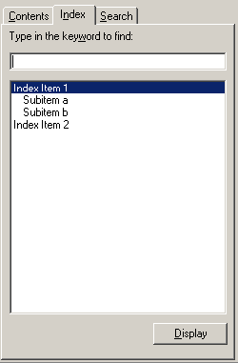
Figure 14-11. Combined index entries
Adding Cross-References
There are three ways to cross-reference Help topics within HTML Help:
- Use standard HTML hyperlinks to create a link from one Help topic to another. Hyperlinks allow one-to-one relationships.
- Use the Related Topics command to create a link from one topic to a list of other specific topics files.
- Use associative links (ALinks) to create links from one topic to a list of other topics based on keywords entered in those topic files.
Because you already know how to create hyperlinks (by now, you’d better), the following sections discuss how to add related topics and create associative links.
Adding Related Topics
You can add related topics as a cross-reference or a hyperlink.
- To add a related topics cross-reference to a Help topic, insert an HTML Help ActiveX control in the topic file. For example, the following object element displays a button that lists two related topics as pop-up menu choices:
- <OBJECT id=hhctrl type="application/x-oleobject"
- classid="clsid:adb880a6-d8ff-11cf-9377-00aa003b7a11"
- codebase="hhctrl.ocx#Version=4,74,9273,0"
- width=100
- height=100>
- <PARAM name="Command" value="Related Topics, MENU">
- <PARAM name="Button" value="Text:Related Topics">
- <PARAM name="Item1" value="Topic 2;Topic2.htm">
- <PARAM name="Item2" value="Topic 3;Topic3.htm">
</OBJECT>
At run time, the preceding HTML appears as shown in Figure 14-12.
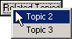
Figure 14-12. Related topics
- To display related topics as a hyperlink instead of as a button control, specify a Text parameter rather than a Button parameter in the object element. For example, the following HTML displays the preceding Related Topics as a hyperlink:
- <OBJECT id= hhctrl type="application/x-oleobject"
- classid="clsid:adb880a6-d8ff-11cf-9377-00aa003b7a11"
- codebase="hhctrl.ocx#Version=4,74,9273,0"
- width=100
- height=100>
- <PARAM name="Command" value="Related Topics, MENU">
- <PARAM name="Text" value="Text:Related Topics">
- <PARAM name="Item1" value="Topic 2;Topic2.htm">
- <PARAM name="Item2" value="Topic 3;Topic3.htm">
</OBJECT>
Creating Associative Links
Associative links reference keywords rather than specific file names. For this reason, they are useful for cross-referencing between HTML Help files—you don’t have to know how the topics within a compiled file are named, you just need to know which keywords were used. Associative links are useful within a single Help file as well—file names can change during development, and it’s easier to maintain a keyword list than it is to update file names within cross-references.
There are two parts to an associative cross-reference:
- The keywords entered in the target topic files provide the destinations that cross-references link to.
- The link entered in the referencing topic file provides the source from which the cross- reference links.
To create associative link keywords, insert an object element in the target topic. For example, the following object element creates the associative link keyword “Link1”:
<Object type="application/x-oleobject"
classid="clsid:1e2a7bd0-dab9-11d0-b93a- 00c04fc99f9e">
<param name="ALink Name" value="Link1">
</OBJECT>
Associative links are very similar to keywords used in indexing HTML Help. However, they do not appear in the index. The reason for this is to allow cross-referencing and indexing to be maintained separately.
To create a link to topics with a specific keyword, insert an HTML Help control ActiveX object in the topic file making the cross-reference. For example, the following object element displays a list of cross-references in a pop-up menu when the user clicks the control:
<OBJECT id=hhctrl type="application/x-oleobject"
classid="clsid:adb880a6-d8ff-11cf-9377-00aa003b7a11"
codebase="hhctrl.ocx#Version=4,74,9273,0"
width=100
height=100>
<PARAM name="Command" value="ALink, menu">
<PARAM name="Button" value="Text:See Also">
<PARAM name="Flags" value=",,1">
<PARAM name="Item1" value="">
<PARAM name="Item2" value="Link1">
</OBJECT>
At run time, the preceding HTML displays a list of topic titles that contain the associative link keyword “Link1”, as shown in Figure 14-13.
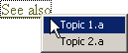
Figure 14-13. Associative links
To display associative links as a hyperlink rather than as a button control, omit the Button parameter from the object element, and call the object’s Click event from the hyperlink. For example, the following HTML displays the links when the user clicks the See Also hyperlink:
<OBJECT id=hhctrl type="application/x-oleobject"
classid="clsid:adb880a6-d8ff-11cf-9377-00aa003b7a11"
codebase="hhctrl.ocx#Version=4,74,9273,0"
width=100
height=100>
<PARAM name="Command" value="ALink, menu">
<PARAM name="Flags" value=",,1">
<PARAM name="Item1" value="">
<PARAM name="Item2" value="Link1">
</OBJECT>

<a href="#" onclick="hhctrl.Click()">See also</a>
Enabling Searches
To enable full-text searches within a Help file, select Compile Full-Text Search Information from the Compiler tab of the Project Options dialog box.
When full-text searching is enabled, the HTML Help Workshop builds a concordance table of all the words in your topic files and includes that table in the compiled Help file. Because this table references all words in the topic files, it can become quite large. To help control the size of this table, you can omit words that are not useful for searching. For example, you might want to omit articles, conjunctions, personal pronouns, and numbers from full-text searching.
To omit words from full-text searching, follow these steps:
- Create a text file listing the words to omit.
- On the Project tab in HTML Help Workshop, click Change Project Options.
- On the Files tab of the Options dialog box, type the file name of the list of words to omit in the Full Text Search Stop List File box.
When a user tries to search on a word that you include in the stop list, HTML Help displays a message box stating that the phrase can’t be searched on.
Compiling and Previewing Help
To compile an HTML Help project, choose one of the following methods:
- On the Project tab of the HTML Help Workshop, click Save All Files And Compile.
- Use the HTML Help Compiler (hhc.exe) from the command line. For example, the following command line compiles the HelpSample.hhp Help project:
hhc.exe HelpSample.hhp
To preview a compiled HTML Help project, choose one of the following methods:
- Click the View Compiled File toolbar button, and then select the file name of the compiled file.
- Double-click the compiled Help file (.chm) in Windows.
IMPORTANT
You can’t recompile a Help file while the compiled Help file is open for viewing. You must close the compiled Help file before recompiling.
Lesson 3: Linking HTML Help to Web Forms
In this lesson, you’ll learn how to display HTML Help from within a Web form. This lesson expands on the techniques introduced in Lesson 1 by showing the different ways you can display HTML Help, describing the differences between compiled and noncompiled Help, and explaining how to make Help respond to user actions in a Web application.
After this lesson, you will be able to
- Display compiled and noncompiled HTML Help using the HTML Help Viewer
- Display HTML Help in an ordinary browser window
- Cause different Help topics to be displayed, depending on which controls in a Web form have the focus
Estimated lesson time: 10 minutes
Displaying the HTML Help Viewer
As shown in Lesson 1, HTML Help is displayed in the HTML Help Viewer using the showHelp method. How you use showHelp depends on whether your HTML Help is compiled:
- Noncompiled Help can be displayed using the address of the Help topic via the Internet, as shown here:
<a href="#" onclick="window.showHelp('Topic1.htm')">Help!</a>
- Compiled Help must be copied locally before you can display topics using showHelp, as shown here:
<a href="#" onclick="window.showHelp('c:\\Help\\HelpSample.chm')">Help!</a>
The HTML Help Viewer is displayed differently depending on whether the Help file is compiled, as shown in Figure 14-14.
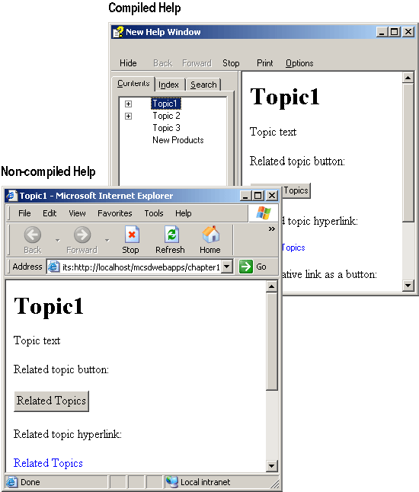
Figure 14-14. Compiled vs. noncompiled Help
As you can see in Figure 14-14, compiled Help displays Contents, Index, and Search features, while noncompiled Help displays only the requested Help topic file. By using compiled Help, you get the full features of the HTML Help system; however, the user must first download the compiled Help file.
To download a compiled Help file to the user’s machine, create a hyperlink to the compiled Help file and provide the user with instructions on where to save the Help file. For example, the following HTML creates a hyperlink that downloads the HelpSample.chm file and instructs the user to save the file to a specific folder:
<a href="HelpSample.chm">Click here</a> to download the sample Help file and
then save the file to the C:\Help folder on your computer.</p>
When the user clicks the preceding hyperlink, the browser asks the user whether he or she wants to open or save the Help file. When the user saves the file to the specified directory, the showHelp method can display topics from the file.
Displaying HTML Help in the Browser
The showHelp method isn’t the only way to display compiled Help files. You can also display topics in the browser using URLs from within the Help file itself. The browser can’t display HTML Help’s Contents, Index, or Search features, but it can open topics from the compiled file across the Internet, which is something showHelp can’t do!
To display a compiled Help file in the browser, create a hyperlink using the topic file’s URL within the compiled file. For example, the following hyperlink displays Topic1.htm in a new browser window:
<a href="ms-its:http://www.mycompany.com/Help/HelpSample.chm::/topic1.htm"
target="HelpWin">Show Help</a>
The preceding hyperlink uses the ms-its: pluggable protocol and the Help path syntax to display a topic file from within a compiled Help file stored on the Web. The ms-its: protocol is provided in Internet Explorer versions 4.0 and later. The HTML Help path syntax has the form compiledfile::/topicfile, where compiledfile is the URL for the compiled Help file and topicfile is the HTML topic file name within the compiled Help file.
Displaying Context-Sensitive Help
If you’re displaying compiled HTML Help in the HTML Help Viewer, you can use context IDs to identify topics within the Help file and associate those topics with tasks in your Web application. This type of Help is called context-sensitive Help because the topic displayed depends on the current context (or task) within the application.
Trying to display context-sensitive Help within a Web application presents a couple of challenges:
- Although you can capture the Help key (F1) using the onkeydown event and the window.event.keyCode property, you can’t cancel the default action for F1 within Internet Explorer. The default action is to display Internet Explorer Help.
- The contextID argument for the showHelp method doesn’t work from within a Web form or an HTML page.
To solve these problems, you must choose a mechanism other than F1 to display Help within your Web application, and you must use the HTML Help path syntax to display the appropriate Help topic. The following HTML uses the onfocus event to display different Help topics as the user moves between controls on a Web form:
VBScript
<HTML>
<HEAD>
<title>Context Help</title>
<script language="vbscript">
Dim LastTopic

Sub ShowContextHelp(Topic)
If (document.all("chkHelp").checked And LastTopic <> Topic) Then
' Display Help for this context.
window.showHelp "c:\help\HelpSample.chm::/" & Topic
' Store topic name.
LastTopic = Topic
End If
End Sub
</script>
</HEAD>
<body onfocus="ShowContextHelp('Topic1.htm')>
<form id="WebForm2" method="post" runat="server">
<H2>Context Sensitive Help</H2>
<INPUT onfocus="ShowContextHelp('Topic2.htm')" type="text">
<BR>
<INPUT onfocus="ShowContextHelp('Topic3.htm')" type="button"
value="Button">
<BR>
<INPUT id="chkHelp" type="checkbox" name="chkHelp">Show user
assistance.
</form>
</body>
</HTML>
JScript
<HTML>
<HEAD>
<title>Context Help</title>
<script language="jscript">
var LastTopic;

function ShowContextHelp(Topic)
{
if ((document.all("chkHelp").checked) && (LastTopic != Topic))
{
// Display Help for this context.
window.showHelp("c:\\help\\HelpSample.chm::/" + Topic);
// Store topic name.
LastTopic = Topic;
}
}
</script>
</HEAD>
<body onfocus="ShowContextHelp('Topic1.htm')">
<form id="WebForm2" method="post" runat="server">
<h2>Context Sensitive Help</h2>
<INPUT type="text" onfocus="ShowContextHelp('Topic2.htm')">
<br>
<INPUT type="button" value="Button"
onfocus="ShowContextHelp('Topic3.htm')">
<br>
<INPUT id="chkHelp" type="checkbox">Show user assistance.
</form>
</body>
</HTML>
The CheckBox control allows the user to turn on context-sensitive Help. At run time, the ShowContextHelp procedure displays the Help topic for each item on the page when the focus changes to a new item, as shown in Figure 14-15.
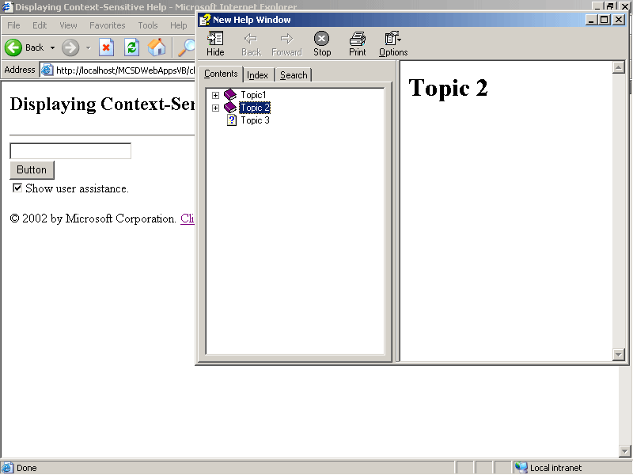
Figure 14-15. Context-sensitive Help
Summary
- You can provide user assistance within Web applications by using ToolTips, Web forms or HTML pages, or HTML Help.
- HTML Help provides built-in Contents, Index, and Search capabilities.
- Use the window object’s showHelp method in client-side scripts to display the HTML Help Viewer.
- Use the HTML Help Workshop to create HTML Help projects and to compile HTML Help.
- Use the HTML Help ActiveX object to add index keywords, related topics, and associative links to Help topics.
- To display compiled Help files from a Web application, you must first download the file to the user’s machine.
Lab: Building and Using an HTML Help File
In this lab, you’ll create a compiled HTML Help file containing several topics and contents, Index, and Search features. You’ll then link the Help file to a Web application.
Estimated lesson time: 30 minutes
Exercise 1: Create a Help Project

In this exercise, you’ll use the skills you learned in Lesson 2 to create a new HTML Workshop Help project, create five Help topic files, and add those files to the Help project. To keep this exercise simple, the content of the Help topic files is minimal, although you can supply any additional content you feel like creating.
To create a new HTML Help project
- Start the HTML Help Workshop. Choose New from the File menu, select Project from the New dialog box, and then follow the New Project Wizard pages to create an empty project in a folder named HelpDemo on your computer.
- Create five new HTML files titled Topic1 through Topic5. Add headings and save the files as shown in the following table:
Title | Heading | Save as
<title>Topic1</title> | <h1>Topic1</h1> | Topic1.htm
<title>Topic2</title> | <h2>Topic2</h2> | Topic2.htm
<title>Topic3</title> | <h3>Topic3</h3> | Topic3.htm
<title>Topic4</title> | <h3>Topic4</h3> | Topic4.htm
<title>Topic5</title> | <h2>Topic5</h2> | Topic5.htm
- Add each of the topic files to the Help project. When complete, the HTML Help Workshop should appear as shown in Figure 14-16.
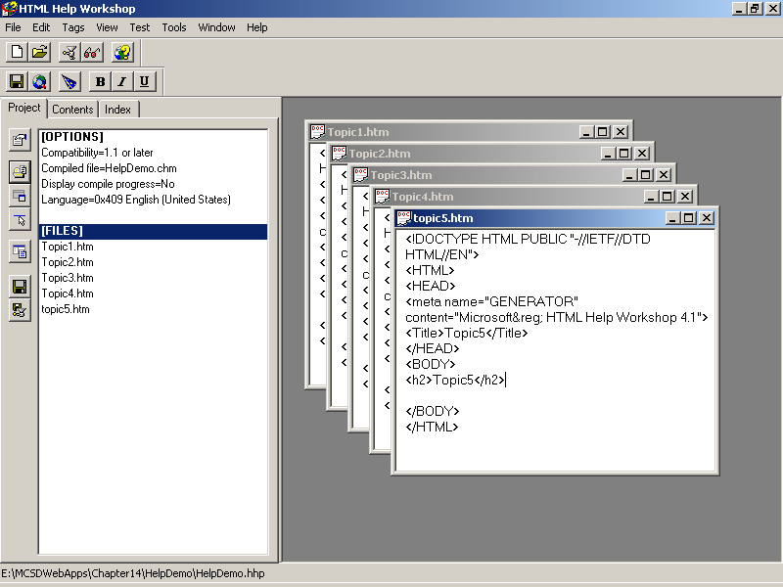
Figure 14-16. Creating a Help project
Exercise 2: Enable Contents, Index, and Search
In this exercise, you’ll continue to use the skills you learned in Lesson 2 to automatically generate Contents, Index, and Search features when the Help project is compiled.
To enable Contents, Index, and Search features
- In the Help project’s Options dialog box, click the Files tab, select check boxes to automatically create a contents file and to include keywords in the index, and then type names for the contents and index files, as shown in Figure 14-17.
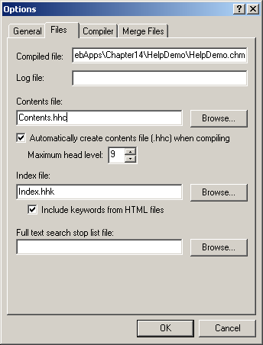
Figure 14-17. Creating contents and index files automatically
- Click the New button on the HTML Help Workshop toolbar, and select Index file to create a new, empty index file. Save the file as Index.hhk. This file must exist in order for the Help compiler to build the index entries.
- Click the Compiler tab, and select the Compile Full-Text Search Information check box, as shown in Figure 14-18. Click OK to close the dialog box.
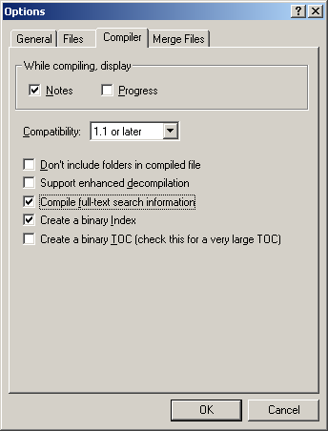
Figure 14-18. Enabling full-text searches
- On the Project tab of the HTML Help Workshop, click Save All Files And Compile. The Workshop builds the contents, index, and search information and then compiles the file and displays a log of the results, as shown in Figure 14-19.
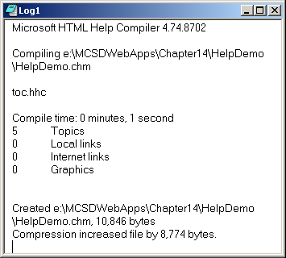
Figure 14-19. Compiler log
- Click View Compiled File on the HTML Help Workshop toolbar, enter the location and name of the HelpDemo.chm file in the View Compiled File dialog box, and then click View. The Workshop displays the compiled Help file, as shown in Figure 14-20.
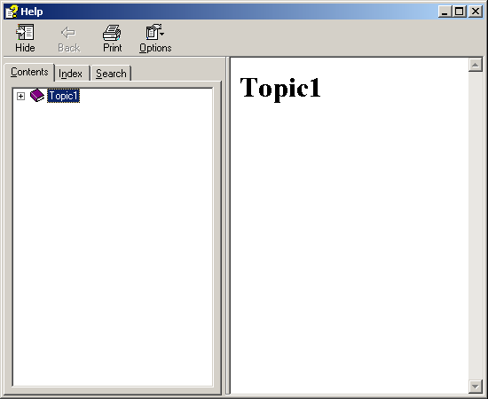
Figure 14-20. Compiled Help
Exercise 3: Add Index Keywords
In this exercise, you’ll add indexed keywords to the Help topic files and then recompile the Help file to create automatic index entries.
To add index keywords to topic files
- In the HTML Help Workshop, open the Topic2.htm topic file, and insert a new line between the <body> </body> tags.
- From the Edit menu, choose Compiler Information. The Workshop displays the Compiler Information dialog box.
- Click Add, type “Item1” as the name of the index keyword to add to the topic, and then click OK. Click OK again to close the Compiler Information dialog box and add the index entry to Topic2.htm. The following HTML shows the generated text that’s added to Topic2.htm:
- <Object type="application/x-oleobject"
- classid="clsid:1e2a7bd0-dab9-11d0-b93a-00c04fc99f9e">
- <param name="Keyword" value="Item1">
</OBJECT>
- Copy the preceding HTML to each of the other topic files. Add or change the keyword parameters to create different keywords. For example, the following HTML inserts three index keywords in a topic file:
- <Object type="application/x-oleobject"
- classid="clsid:1e2a7bd0-dab9-11d0-b93a-00c04fc99f9e">
- <param name="Keyword" value="Item1">
- <param name="Keyword" value="new">
- <param name="Keyword" value="improved">
</OBJECT>
- If the Help file from Exercise 2 is open, close it. Recompile the Help project, and view the resulting index. It should appear similar to Figure 14-21.
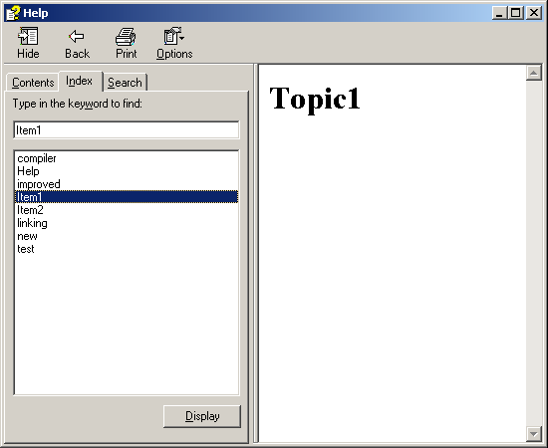
Figure 14-21. Keywords in the index
Exercise 4: Link Help to a Web Form
In this exercise, you’ll use the skills you learned in Lesson 3 to link the compiled Help you created in the preceding exercises to a simple Web form.
To link compiled Help to a Web form
- Create a new, empty Web application project named vbHelpDemo or csHelpDemo.
- Add the following HTML to Webform1 to instruct the user how to download the Help file and to provide a way to display Help on the Web form:
- <p>To use Help with this Web form:</p>
- <ol>
- <li><a href="HelpDemo.chm">Click here</a> to download Help.</li>
- <li>Save the file to the c:/help folder on your computer.</li>
- <li>Then use the buttons below to display Help topics.</li>
- </ol>
- <INPUT type="button" value="Show Help" onclick="window.showHelp('c:\\help\\HelpDemo.chm')">
- <br>
- <INPUT type="button" value="Show Topic3" onclick="window.showHelp('c:\\help\\HelpDemo.chm::/Topic3.htm')">
- <br>
<INPUT type="button" value="Show Topic5" onclick="window.showHelp('c:\\help\\HelpDemo.chm::/Topic5.htm')">
- Copy the compiled Help file created in the preceding exercises to the Web application project directory.
- Run the Web application. After you download the Help file, clicking the HTML Button controls display Help, as shown in Figure 14-22.
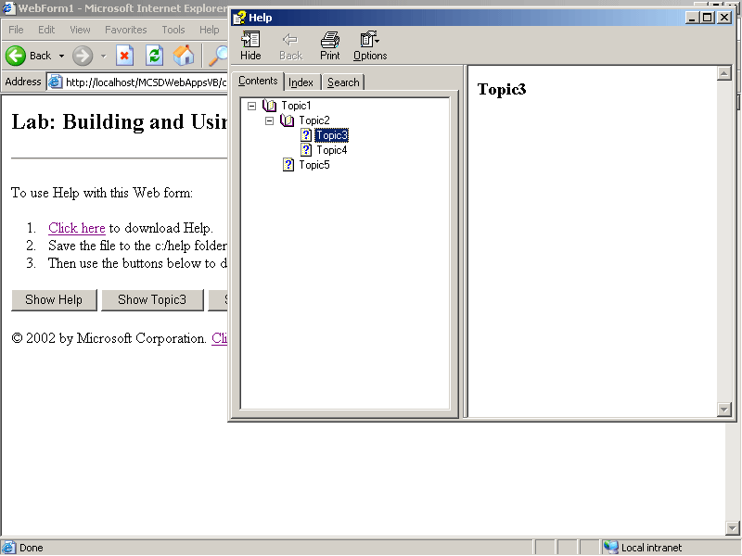
Figure 14-22. Displaying Help from a Web form
Review
The following questions are intended to reinforce key information presented in this chapter. If you are unable to answer a question, review the appropriate lesson and then try the question again. Answers to the questions can be found in the appendix.
- Which HTML attribute does the server control’s ToolTip property map to in the HTML rendered by ASP.NET?
- How does displaying HTML Help using the window object’s showHelp method differ from displaying HTML Help using a browser window?
- How do you add index keywords to a Help topic?

